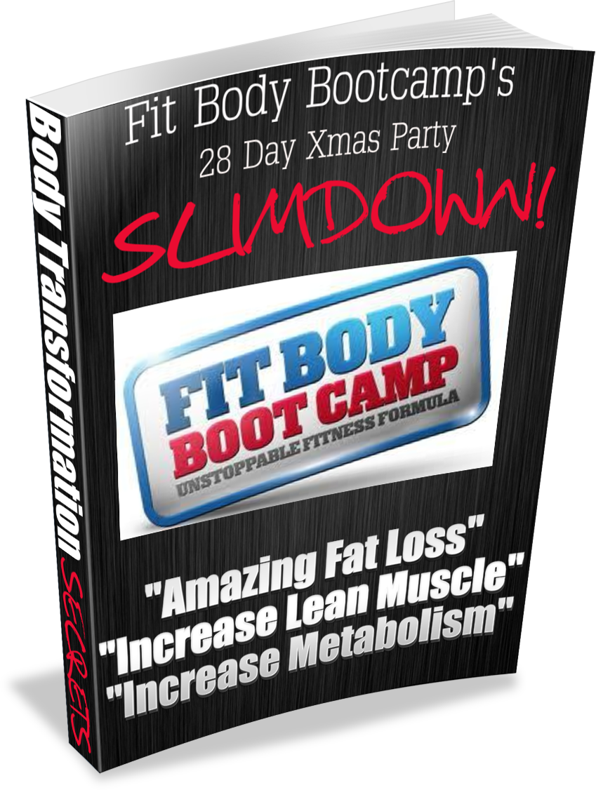

The 28 Day Xmas Party Fit Body Bootcamp manual isn’t another gimmicky diet or a starvation plan that will put you in a circle of weight loss and weight gain.

If you are looking for a quick fix diet or fad then it’s probably best if you stop reading now.

What FBBC believe passionately in is giving our clients the right information and also an explanation of key nutritional habits.

This will allow you to lose body fat, achieve lasting results and enjoy your new healthy, lean, slim body for years to come without having to deny yourself the odd treat.

Step 1

The first step is one of the most pivotal aspects of the program.

Having small and often meals is recommended on TV and in the magazines almost on a daily basis but rarely do we ever hear why this is recommended.

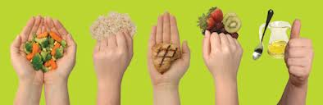

There is no need to count calories, instead use this simple rule: For salads/veg as much as you can fit into both hands.

Carbs a fist size is one serving. Protein palm size (female) hand size (male) Good fats should be around 1-2 thumb-sized measure.

Every time we eat (especially protein) our metabolism is increased because we need energy to digest and process foods. The technical term for this is the Thermogenic Effect of food.

Put simply the more frequently we eat the more we can stimulate MR (metabolic rate). Most adults in the UK tend to skip meals and leave hours in between feeds, therefore allowing MR to slow down.

The body then perceives a famine and promotes fat storage as opposed to fat burning.

Don’t eat more, just more often! Every 3 hours in fact, aim for a total of 5-6 small meals and snacks per day. A good meal schedule for most people to follow would be:

7am: Breakfast 10am: Small snack 1pm: Lunch4pm: Small snack 7pm: Evening meal 9-930pm: Small snack (Only if needed)

Step 2

Now its time to get rid of the things that we know we shouldn’t be eating.

From now on the following should be off the menu for at least the next 28 Days (Apart from parties). Then the occasional treat once per week is good.

Crisps

Chocolate

Cola (All Carbonated drinks)

Diet Soda’s

Any fried foods

Takeaways

Sugary snacks/sweets

Processed microwave foods

Added salt/sugar

Sauces

Alcohol

Step 3

Certain food types such as carbs can, if in a sedentary state, be easily stored away as body fat. So the late night pasta or potatoes have to go.

Here are a few of the most popular carbohydrate foods to avoid in your evening meal.

Potatoes

Rice

Pasta

Bread

Instead opt for salads, stir fry, or steamed veg.

In the early stages of a good nutritional plan. It is vital to see in black and white your food preferences and nutritional habits write it down in a journal.

Do not change everything at once, that’s doomed to fail. But instead aim for an easy to follow transition.

The food journal will allow you to see the things you do well and areas you may need to improve.

Key Points

Eat Small but often every 3 hours

Cut out the junk

Reduce Carbs

Increase Protein

Small Portions

Drink Water (6-8 Glasses)

Don’t Change Everything At Once

Record In Journal

Step 4

So by now you have mastered the fundamental strategy of small & often and made some key changes and hopefully learned a lot about your eating habits both good and bad.

Now lets build on that success by eating the right foods at the right times.

Gone are the days of calorie counting as the only approach. What is key to your success is to understand the differences between the food groups and how they can effect your body composition.

Body composition is the KEY word here because weight loss can be from muscle and water as well as fat, which can be catastrophic to your metabolism.

Muscle takes up a lot less space in the body than fat and by increasing the muscle you have you can super charge your resting metabolism. The more muscle you have, the more fat you will burn.

Protein

Aim to have some form of protein in a least 3 of your daily meals if not all.

Protein will offset hunger and cravings and also allow your body to recover from your Fit Body Bootcamp workouts, and also increase your metabolism by adding new muscle tone.

Great sources of protein are as follows:

Chicken breast (no skin)

Eggs

Whey protein shakes (mixed with water)

Lentils

Fish

Tofu

Carbs

Now I have long since lost count of how many diet plans are out there which cut out carbs completely from your diet.

It’s safe to say I’m not a fan of any so-called diet that completely eliminates an entire food group!

Especially one which is key to providing you with the energy to not alone exercise but to go about your day-to-day life.

For the sake of simplicity we are going to split carbs into two groups, avoid and consume.

The ones we are going to avoid are the simple or refined carb sources (High GI)

The ones we are going to be consuming (at the right times in the right amounts) are complex (Low GI)

Avoid

White rice

White pasta

White bread

Chips

Large amounts of fruit or fruit juices

Consume (At the right times)

Brown/Whole meal bread

Brown rice

Whole wheat pasta

Sweet potatoes

Vegetables

Timing is key

As carbohydrates are the body’s preferred fuel source for energy it is important we have enough but and there is a but only have them early in the day or in small amounts in the meal post exercise. Otherwise the body will take the surplus and put it in the reserve tank (stored body fat)

For 99% of people following this plan breakfast and lunch are good times to have small portions of carbohydrates no more than the size of your fist.

Fats

Good fats are essential for a healthy diet, in fact the right amounts of good fats in your daily diet can in fact help you metabolism bad fats.

Bad fats are well, bad!

To ensure you are getting enough do the following……

With your mid morning snack take two fish oils capsules or omega 6 & 9.

In your evening meal add half a tablespoon of extra virgin olive oil or mix in half an avocado to your salad.

Step 5

To see good results you need to attend at least 3 Fit Body Bootcamp sessions per week, it is important to keep track.

As true as the rule “You cant out train a bad diet” it is also a fact that without putting in the effort you wont get results. Don’t just attend push yourself!

Step 6

So many times people ask me “What should I eat” “Can you give me a diet plan?”

Well the answer to the first question is what do you like to eat that is good for you?

The key to your own personal nutrition is to learn the key principles for your own specific goal.

If the goal is fat loss, then the key is to find what works for you so you can stick to it.

Eating Clean

Eating clean basically means eating food as close (as possible) to its natural state.

If it didn’t fly, walk, swim or grow then chances are it’s better off avoided.

A good way of checking is if it was around 100 years ago then go for it.

As a society we have created so many problems with food processing, additives etc. The list goes on.

We have created so many different food related medical problems in the last 50-100 years its sad, but true.

Detox

Eating clean and cutting out toxins such as alcohol, caffeine, and food additives will also help your body to detox.

When this occurs everything works better, including you guessed it FAT BURNING!

The livers main function is to detoxify us, if it is constantly toxins we eat then its not going to be very efficient at metabolizing body fat.

Breakfast Ideas

Low-calorie muesli (no added sugar or salt) add ¼ bowl of natural yogurt and mix with chopped strawberries or blueberries.

½ cup of porridge oats, mixed with water or almond milk add a handful of almond nuts.

On the run breakfast 1-2 scoops (1 female) (2 male) of whey protein mixed with water or almond milk with 1 banana.

Snack Ideas

5-10 Almonds and an apple

Protein shake

Low calorie, low fat protein bar (1/2 Female)

1-2 Oatcakes with thin spread of whole earth peanut butter

Lunch Ideas

Chicken breast (1/2 Female) Chopped salad, peppers, tomatoes, spinach, avocado (Chicken can easily be replaced with any protein source)

½ Whole meal pita bread, Tuna, cucumber, lettuce, sweetcorn (Low Fat Mayo) (Tuna can easily be replaced with any protein source)

Chicken breast pieces (handful) and veg pot mix together in a microwavable container (chicken can easily be replace with any protein source)

Afternoon Snack Ideas

5-10 Almonds and an apple

Ready to drink protein shake

Low calorie, low fat protein bar (1/2 Female)

1-2 Oatcakes with thin spread of whole earth peanut butter

Evening Meal Ideas

Chicken Stir Fry (No source or noddles) Add bean sprouts cayenne pepper (small) to season or reduced salt soy source (small)

Salmon Salad, spinach, peppers, tomatoes, season with balsamic vinegar

Lentil Stew Pot, add veg plus lentils, chopped tomatoes and boil with 1 veg stock cube.

Advanced Fat Loss Tips

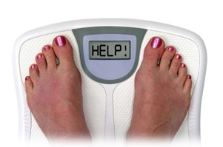

Drink Green Tea

Several researches have proven that green tea is rich in catechins. The strongest catechin in green tea is known as epigallocatechin gallate (EGCG). Most experts claim that EGCG increases the rate at which fat is burned, and reduces the absorption of calories from the diet.

Take CLA

Over two decades of research have shown CLA may significantly help reduce body fat, and there's even recent evidence to support that it increases muscle tissue. Primarily, though, athletes and people who are weight conscious have begun supplementing with CLA because it's been shown in research to significantly shift body composition in favor of fat loss and muscle gain.

Drink Ice Cold Water

The human body is constantly trying to maintain a static temperature. The colder the surrounding or internal conditions, the more calories the body burns. Metabolism acts like a furnace that must burn fuel to keep the body warm. Luckily, the body’s fuel of choice for keeping warm is fat!

What To Do The Day Of & Day After A Xmas Party

Over the xmas period with all the works parties and social occasions it is very common for people to gain body fat. By following this protocol you can limit or avoid any negative effects altogether!

Assuming the event is in the evening during the day drink an extra litre of water than your normal intake and cut out carbs completely only consuming protein veg or salads.

Enjoy the evening but don’t go over board on snacks and alcohol.

The following day fast (No food) until 3pm and again drink more water. Consume a greens drink (www.fbbcleangreens.com) and have one small meal in the evening.

This should be enough to get you started on your journey to fantastic results, please reach out to us at coaching@mkfitbody.com for any questions

Neil & Helen Fbbc

